Session-2 Lab Program

1. Finding Unique Elements in a List

Code:
n = int(input("Enter number of elements: "))
arr = []
for i in range(n):
arr.append(int(input()))
unique = []
for x in arr:
if x not in unique:
unique.append(x)
print("Unique elements:", unique)

Output:
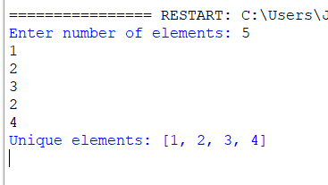

2. Bubble Sort
Code:
arr = ["abc", "car", "ada", "racecar", "cool"]
arr = [64, 34, 25, 12, 22, 11, 90]

n = len(arr)
for i in range(n):
for j in range(0, n - i - 1):
if arr[j] > arr[j + 1]:
arr[j], arr[j + 1] = arr[j + 1], arr[j]
print("Sorted array:", arr)

Output:
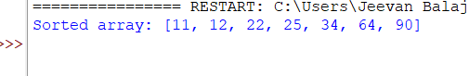

3. Binary Search
Code:
arr = [10, 20, 30, 40, 50, 60, 70]
x = int(input("Enter the number to search: "))
low = 0
high = len(arr) - 1
found = False
while low <= high:
mid = (low + high) // 2
if arr[mid] == x:
found = True
break
elif arr[mid] < x:
low = mid + 1
else:
high = mid - 1
if found:
print("Element found")
else:
print("Element not found")

Output:
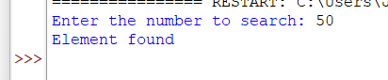

4. Heap Sort
Code:
def sortArray(nums):
n = len(nums)
def heapify(n, i):
largest = i
left = 2 * i + 1
right = 2 * i + 2
if left < n and nums[left] > nums[largest]:
largest = left
if right < n and nums[right] > nums[largest]:
largest = right
if largest != i:
nums[i], nums[largest] = nums[largest], nums[i]
heapify(n, largest)
for i in range(n // 2 - 1, -1, -1):
heapify(n, i)
for i in range(n - 1, 0, -1):
nums[0], nums[i] = nums[i], nums[0]
heapify(i, 0)
return nums
nums = [5, 2, 3, 1]
print(sortArray(nums))

Output:
